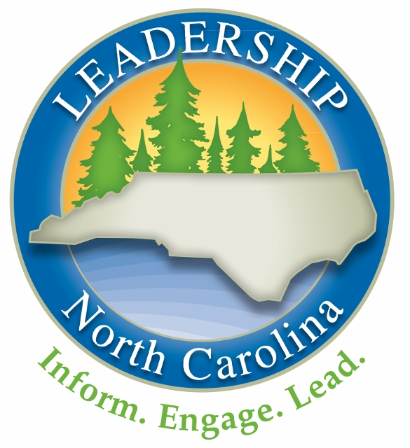

**LNC Learning Teams**

**Post-Orientation Call Recording Form**

Use this form to record highlights of your monthly learning team calls. Return your completed form to Mike Cole at [mikec@amazingstudiosinc.com](mailto:mikec@amazingstudiosinc.com) by Friday, October 26th.

**Post-Orientation Session Discussion Prompts**

Remember, these prompts are just to get you started. Use your calls however proves most useful to your team.

* Finish sharing any introductions you didn’t get to during Orientation (day job, night job, amount of time in NC, one thing no one is likely to know about you, why you are excited to be part of LNC, one question you hope to have answered by the LNC program).
* What are the main takeaways from Orientation?
* How are you feeling as you leave Orientation and head into your first session (Government)?
* Talk about how your team will use the LNC Learning Model during sessions and on your calls.

**Team Number and Name:**

**Team Navigator:**

**Date and Time of Call:**

**Call Highlights:**